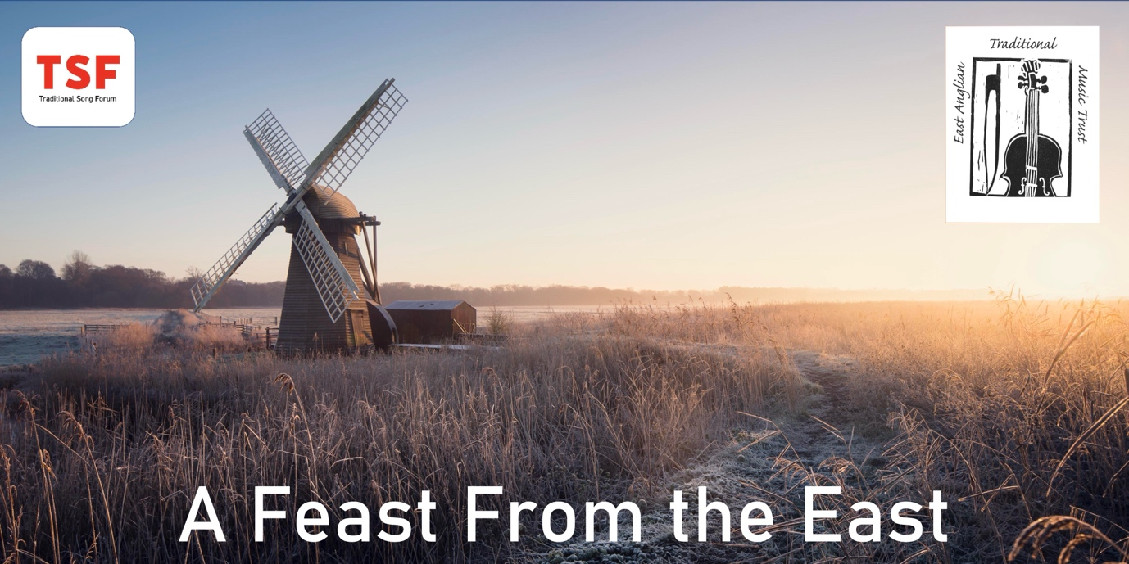

TSF Spring Conference – A Feast from the East, Saturday 6 April 2024

Thank you for booking a place on our forthcoming event. Please find below final housekeeping details for the Traditional Song Forum Spring Conference.

Venue details:
Stowmarket Scout Centre, Milton Road North
IP14 1EX (A14 Junction 49 if travelling from Cambridge direction, Junction 50 if from Ipswich or A140 from Norwich).

Doors will open at 9.30am.

Car Parking:
There are very limited car parking spaces at the Scout Centre (and very active traffic wardens!) so please park in the Long Stay car parks across the town (£2.50 all day). If you are a Blue Badge driver, please contact TSF for further details. A link to the town’s car parks can be found HERE: https://www.eatmt.org.uk/getting-to-parking-and-staying-in-stowmarket/

Finding the Venue on foot:
The venue can be accessed within a 7-10 minute walk from Stowmarket Train Station and can be accessed on foot via Gipping Way (situated between ‘Halo’ on the corner of Station Road West/traffic lights on Gipping Way and the Stowmarket Town Council on the junction of Gipping Way and Milton Road South).

For people travelling from the Town Centre car parks, The Scout Centre can be found very close to Stowmarket Library, the John Peel Centre and The Parish Church of St Peter’s and St Mary’s on Church Walk. From the Market Place/Ipswich Street it can be accessed through walkways in Lime Tree Place and/or Fox’s Yard.

The hall has disabled access and facilities.

Refreshments:
Tea, coffee and biscuits/cakes will be available to purchase at various points in the day. Lunch will not be provided so please either BYO or use local cafes. We can strongly recommend the two nearest eateries - Osier Café (within the Parish Church) or Passione D’Amore in Fox Yard – but there really is plenty of choice for food both at lunchtime and in the evenings if you are staying.

Filming:
This event is being filmed on the day by Jake Lee Savage. Please let Jake if you don’t want to feature on this film if you think you may be in view of the camera lens!

Lunchtime singing:
We are proposing to have small number of songs sung during the lunch hour. Eammon Andrews, a local singer and EATMT Trustee will be MC. There will be more details about this at the start of the event.

Day timetable:
10am Welcome!
10.15am Katie Howson – Fred Whiting – A Life in Songs
11.00am Alan Helsdon – Walter Pardon – Craftsman & Singer
BREAK
12.00pm Martin Nail – Walter’s Dark Arches
12.30pm Robert Ashton – Where are the Fellows who Cut the Hay?
1.00-2.00 Lunch – including Song, Stalls, Exhibition viewing
2.00pm Hazel Marsh - Singers & Songs – Gypsy and Traveller Voices in Music Archives
2.30pm Chris Holderness – Des & Me – Collecting Musical Memories in Norfolk
3.00pm Chris Heppa – E J Moeran in Norfolk – ‘An Assiduous Collector?’
BREAK
4.00pm John Marshall-Potter & Simon Saunders – The Blaxhall Ship Project
4.30pm Discussions, Winding up and Farewells

More music and song:
Some people will be arriving on the Friday evening and some staying on the Saturday evening. One of our music friendly pubs, The Walnut (Violet Hill Road, IP14 1NE) welcomes Singers and Musicians on the Friday night but has an event running on the Saturday. If we manage to secure a suitable pub for the Saturday night too, then we will make that announcement on Saturday during the day.

On Sunday 7 April, from around 1.30pm, one of our speakers, Robert Ashton, will be officially launching his book “Where are the Fellows who Cut the Hay” in Blaxhall Village Hall (IP12 2DH) as well as unveiling a Blue Plaque for George Ewart Evans. This is a free event taking place in a very special place known for Traditional Song and Music and Robert extends a warm welcome to you all.

Looking forward to seeing you on Saturday.

Best wishes from the TSF and EATMT teams

