Morris Dancing
With thanks to local dancers Sue Lawrence and Dave Evans for co-ordinator the Morris sides.
We are delighted to welcome 6 East Anglian based Morris sides demonstrating three styles of Morris Dancing found in the UK.
There will be dancing spots around the town at 11-11.45; 12-12.45; 2-2.45; 3-3.45 with a 4pm finale. You can find the dancers in the main high street, Asda precinct, Stowmarket church grounds, Queens Head car park, Lime Tree Place and at approximately 4 in the Market Place.
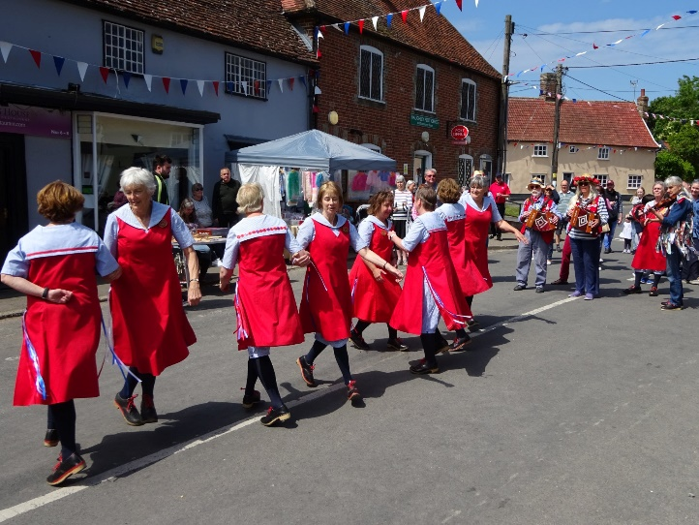
Local side Haughley Hoofers are a North West Clog side. They practice during the autumn and winter months on a Sunday evening in the local village of Haughley and are always keen to welcome new dancers/wannabe dancers.
Email: suemike.lawrence@gmail.com

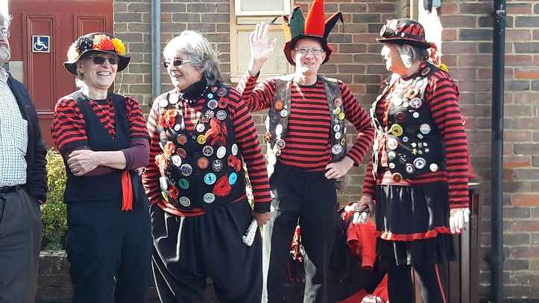
Colchester based AnnieMation are our 2nd North West Clog side joining us for the day. AnnieMation are a mixed side and practice in the Autumn and Winter months on a Sunday from October 11am-1pm at Roman Circus House in Colchester.
Email: anniemationclog@gmail.com

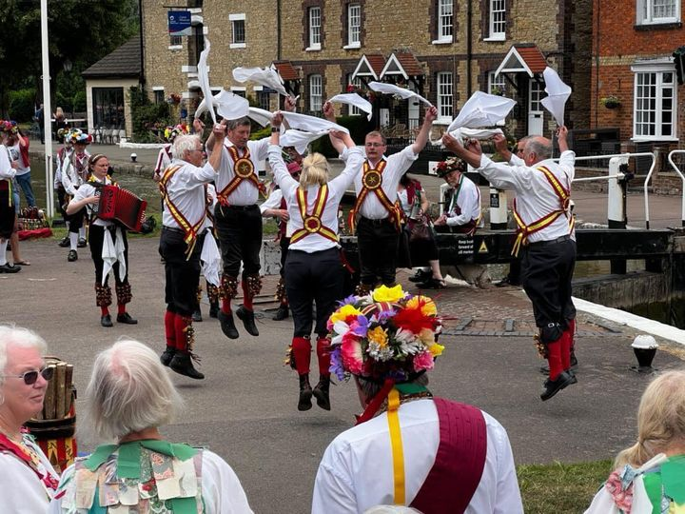
Golden Star Morris are a mixed Cotswold side based in Norwich. They welcome new dancers and start practices again on Sunday 25th September (with a “taster session” on Sunday 11th September) 7-9pm at St Catherine’s church hall on the Aylsham Road, Norwich.
Email: bagman.goldenstarmorris@gmail.com

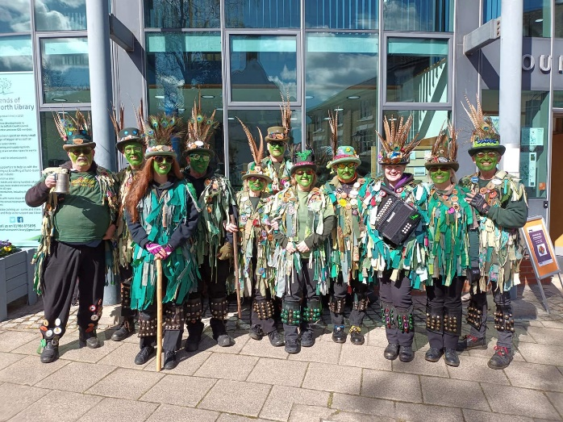
Green Dragon Morris are a mix Border side based in Bury St Edmunds. They welcome new dancers and start practices again in the Autumn on Monday evenings 8-10pm at Risbygate Sports Club.
Email: gdbagman@gmail.com

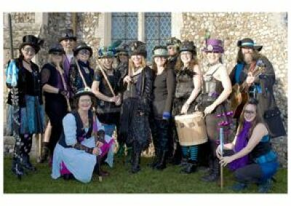
Boudicca Morris are a border Morris side hailing from the Suffolk/Essex border. They meet from September on Thursday evenings at the Old School Bridge House in Hadleigh (Suffolk) from 7pm.

Email: boudiccabordermorris@hotmail.com
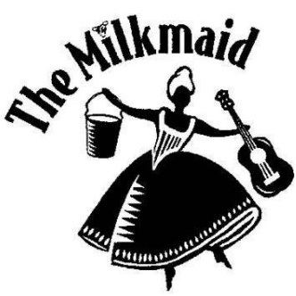MILKMAID MOLLY
A Molly dance group for adults with learning disabilities and experienced dancers based in Bury St Edmunds.
Facebook: https://www.facebook.com/milkmaidmolly/community/?ref=page_internal
website: http://www.milkmaidcentre.com/molly/

